Name: | Vasundhara Singh
UID no.: | 2021700062
Experiment No. | 5
Class: | SE CSE(DS)
Batch: | D-4
Date of Experiment: | 20/03/2023

AIM: | Implement Dynamic Programming for Matrix Chain Multiplication
PROBLEM STATEMENT: | Find the minimum possible number of multiplications and corresponding optimal order of multiplication of matrices
THEORY: | It is a Method under Dynamic Programming in which previous output is taken as input for next.  Here, Chain means one matrix's column is equal to the second matrix's row [always].  In general:  If A = ⌊a_{ij}⌋ is a p x q matrix  B = ⌊b_{ij}⌋ is a q x r matrix  C = ⌊c_{ij}⌋ is a p x r matrix  Then  Given following matrices {A₁,A₂,A₃,...A_{n}} and we have to perform the matrix multiplication, which can be accomplished by a series of matrix multiplications  A₁ xA₂ x,A₃ x.....x A_{n}  Matrix Multiplication operation is associative in nature rather commutative. By this, we mean that we have to follow the above matrix order for multiplication but we are free to parenthesize the above multiplication depending upon our need.  In general, for 1≤ i≤ p and 1≤ j ≤ r  It can be observed that the total entries in matrix 'C' is 'pr' as the matrix is of dimension p x r Also each entry takes O (q) times to compute, thus the total time to compute all possible entries for the matrix 'C' which is a multiplication of 'A' and 'B' is proportional to the product of the dimension p q r.  We can save the number of operations by reordering the parenthesis.
PROGRAM: | #include <limits.h>  #include <stdio.h>  void brac(int i, int j, int n, int* bracket, char * name)  {  // If only one matrix left in current segment  if (i == j) {  printf("%c",(*name));  (*name)++;  return;  }  printf("(");  // Recursively put brackets around subexpression from i to bracket[i][j].  // "*((bracket+i*n)+j)" is similar to bracket[i][j]  brac(i, *((bracket + i * n) + j), n, bracket, name);  // Recursively put brackets around subexpression from bracket[i][j] + 1 to j.  brac(*((bracket + i * n) + j) + 1, j, n, bracket, name);  printf(")");  }  void MCM(int ord[], int size)  {  int m[size][size], s[size][size];  int k, l;  int count;  for(int i=0; i<size; i++)  {  for(int j=0; j<size; j++)  {  m[i][j] = 0;  s[i][j] = 0;  }  }  for(int i = 2; i<size; i++)  {  for(int j = 1; j<size-i+1; j++)  {  l = i+j-1;  m[j][l]= INT_MAX;  for(int k = j; k<=l-1; k++)  {  count = m[j][k] + m[k+1][l] + ord[j-1]*ord[k]*ord[l];  if(count < m[j][l])  {  m[j][l] = count;  s[j][l] = k;  }  }  }  }  for(int i=1; i<size; i++)  {  for(int j = 1; j<size; j++)  {  printf("%d\t", m[i][j]);  }  printf("\n");  }  printf("\n\n");  for(int i=1; i<size; i++)  {  for(int j = 1; j<size; j++)  {  printf("%d\t", s[i][j]);  }  printf("\n");  }  printf("\nOrder of multiplication: ");  char name = 'A';  brac(1, size - 1, size, (int*)s, &name);  printf("\n\n");  printf("Min no. of multiplications: %d ", m[1][size-1]);  }  int main()  {  int n, temo;  printf("Enter no. of matrices: ");  scanf("%d", &n);  int ord[n+1];  printf("Enter order (m n) of matrix 1: ");  scanf("%d%d", &ord[0], &ord[1]);  for(int i = 1; i<n; i++)  {  printf("Enter order (m n) of matrix %d: ", i+1);  scanf("%d%d", &temo, &ord[i+1]);  if(temo != ord[i])  {  printf("Order does not match. Matrices cannot be multiplied. Re-enter.\n");  i--;  }  }  for(int i=0; i<=n; i++)  {  printf("%d ", ord[i]);  }  printf("\n\n");  MCM(ord, n+1);  }
RESULT: | 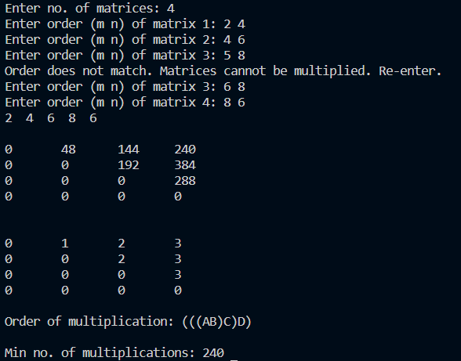
CONCLUSION: | Implemented dynamic programming to solve the problem of matrix chain multiplication.

